**Базовая настройка**

**ISP**

**1.** mcedit /etc/hostname 🡪 ISP

reboot

**2.** mkdir /etc/net/ifaces/ens36 – 37 – 38

3. mcedit /etc/net/ifaces/ens36/options 🡪 TYPE=eth; BOOTPROTO=**dhcp**; ONBOOT=yes

mcedit /etc/net/ifaces/ens37/options 🡪 TYPE=eth; BOOTPROTO=**static**; ONBOOT=yes

mcedit /etc/net/ifaces/ens38/options 🡪 TYPE=eth; BOOTPROTO=**static**; ONBOOT=yes

**4.** Ориентируясь по мак адресам, выдаем апишники:

mcedit /etc/net/ifaces/ens37/ipv4address 🡪 172.16.4.1/28

mcedit /etc/net/ifaces/ens38/ipv4address 🡪 172.16.5.1/28

**5.** mcedit /etc/resolv.conf 🡪 nameserver 77.88.8.8

systemctl restart network

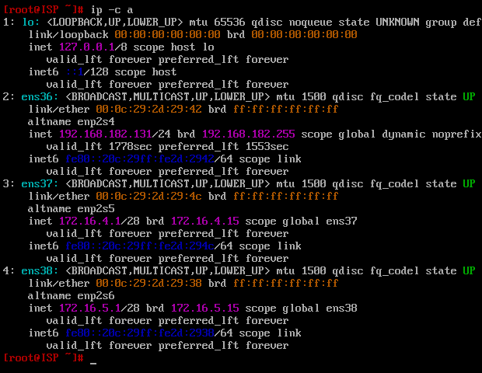

**6.** mcedit /etc/net/sysctl.conf 🡪 net.ipv4.ip_forward=1

sysctl –w net.ipv4.ip_forward=1

**7.** iptables –t nat –A POSTROUTING –o ens36 –s 172.16.0.0/16 –j MASQUERADE

iptables-save > /etc/sysconfig/iptables

systemctl enable --now iptables

**HQ-RTR**

**1.** mcedit /etc/hostname 🡪 HQ-RTR.au-team.irpo

reboot

**2.** mkdir /etc/net/ifaces/ens36 – 37 – 38 – 39

**3.** mcedit /etc/net/ifaces/ens36/options 🡪 TYPE=eth; BOOTPROTO=static; ONBOOT=yes

mcedit /etc/net/ifaces/ens37/options 🡪 TYPE=eth; BOOTPROTO=static; ONBOOT=yes

mcedit /etc/net/ifaces/ens38/options 🡪 TYPE=eth; BOOTPROTO=static; ONBOOT=yes

mcedit /etc/net/ifaces/ens39/options 🡪 TYPE=eth; BOOTPROTO=static; ONBOOT=yes

**4.** Ориентируясь по мак адресам, выдаем апишник:

mcedit /etc/net/ifaces/ens36/ipv4address 🡪 172.16.4.2/28

mcedit /etc/net/ifaces/ens36/ipv4route 🡪 default via 172.16.4.1

**5.** Ориентируясь по мак адресам, создаем сабинтерфейсы:

mkdir /etc/net/ifaces/ens37.200

mkdir /etc/net/ifaces/ens38.100

mkdir /etc/net/ifaces/ens39.999

**6.** mcedit /etc/net/ifaces/ens37.200/options 🡪 TYPE=vlan; HOST=ens37; VID=200; BOOTPROTO=static; ONBOOT=yes

mcedit /etc/net/ifaces/ens38.100/options 🡪 TYPE=vlan; HOST=ens38; VID=100; BOOTPROTO=static; ONBOOT=yes

mcedit /etc/net/ifaces/ens39.999/options 🡪 TYPE=vlan; HOST=ens39; VID=999; BOOTPROTO=static; ONBOOT=yes

**7.** mcedit /etc/net/ifaces/ens38.100/ipv4address 🡪 192.168.100.1/26

mcedit /etc/net/ifaces/ens37.200/ipv4address 🡪 192.168.100.97/28

mcedit /etc/net/ifaces/ens39.999/ipv4address 🡪 192.168.100.113/29

**8.** mcedit /etc/resolv.conf 🡪 nameserver 77.88.8.8

systemctl restart network

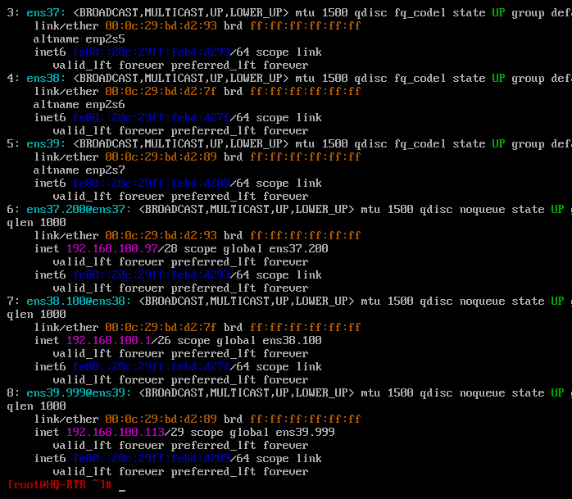

**9.** mcedit /etc/net/sysctl.conf 🡪 net.ipv4.ip_forward=1

sysctl –w net.ipv4.ip_forward=1

**10.** iptables –t nat –A POSTROUTING –o ens36 –j MASQUERADE

iptables-save > /etc/sysconfig/iptables

systemctl enable --now iptables

**11.** apt-get update && apt-get install nano

**BR-RTR**

**1.** mcedit /etc/hostname 🡪 BR-RTR.au-team.irpo

reboot

**2.** mkdir /etc/net/ifaces/ens36 – 37

**3.** mcedit /etc/net/ifaces/ens36/options 🡪 TYPE=eth; BOOTPROTO=static; ONBOOT=yes

mcedit /etc/net/ifaces/ens37/options 🡪 TYPE=eth; BOOTPROTO=static; ONBOOT=yes

**4.** Ориентируясь по мак адресам, выдаем апишники:

mcedit /etc/net/ifaces/ens36/ipv4address 🡪 172.16.5.2/28

mcedit /etc/net/ifaces/ens36/ipv4route 🡪 default via 172.16.5.1

mcedit /etc/net/ifaces/ens37/ipv4address 🡪 192.168.100.65/27

**5.** mcedit /etc/resolv.conf 🡪 nameserver 77.88.8.8

systemctl restart network

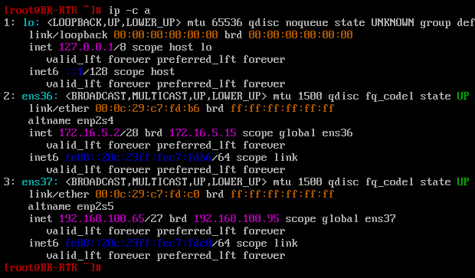

**6.** mcedit /etc/net/sysctl.conf 🡪 net.ipv4.ip_forward=1

sysctl –w net.ipv4.ip_forward=1

**7.** iptables –t nat –A POSTROUTING –o ens36 –j MASQUERADE

iptables-save > /etc/sysconfig/iptables

systemctl enable --now iptables

**8.** apt-get update && apt-get install nano

**HQ-SRV**

**1.** mcedit /etc/hostname 🡪 HQ-SRV.au-team.irpo

reboot

**2.** mkdir /etc/net/ifaces/ens36

mkdir /etc/net/ifaces/ens36.100

**3.** mcedit /etc/net/ifaces/ens36/options 🡪 TYPE=eth; BOOTPROTO=static; ONBOOT=yes

mcedit /etc/net/ifaces/ens36.100/options 🡪 TYPE=vlan; HOST=ens36; VID=100; BOOTPROTO=static; ONBOOT=yes

**4.** mcedit /etc/net/ifaces/ens36.100/ipv4address 🡪 192.168.100.2/26

mcedit /etc/net/ifaces/ens36.100/ipv4route 🡪 default via 192.168.100.1

**5.** mcedit /etc/resolv.conf 🡪 nameserver 77.88.8.8

systemctl restart network

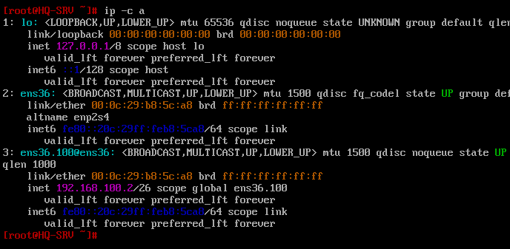

**6.** mcedit /etc/net/sysctl.conf 🡪 net.ipv4.ip_forward=1

sysctl –w net.ipv4.ip_forward=1

**7.** apt-get update && apt-get install nano

**BR-SRV**

**1.** mcedit /etc/hostname 🡪 BR-SRV.au-team.irpo

reboot

**2.** mkdir /etc/net/ifaces/ens36

3. mcedit /etc/net/ifaces/ens36/options 🡪 TYPE=eth; BOOTPROTO=static; ONBOOT=yes

**4.** mcedit /etc/net/ifaces/ens36/ipv4address 🡪 192.168.100.66/27

mcedit /etc/net/ifaces/ens36/ipv4route 🡪 default via 192.168.100.65

**5.** mcedit /etc/resolv.conf 🡪 nameserver 77.88.8.8

systemctl restart network

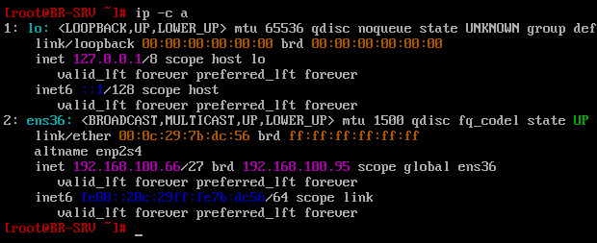

**6.** mcedit /etc/net/sysctl.conf 🡪 net.ipv4.ip_forward=1

sysctl –w net.ipv4.ip_forward=1

**7.** apt-get update && apt-get install nano

**GRE + FRR**

**HQ-RTR**

**1.** mkdir /etc/net/ifaces/gre1

**2.** nano /etc/net/ifaces/gre1/options 🡪

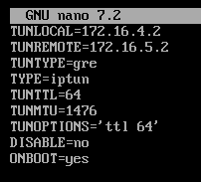

**3.** nano /etc/net/ifaces/gre1/ipv4address 🡪 10.0.0.1 peer 10.0.0.2

systemctl restart network

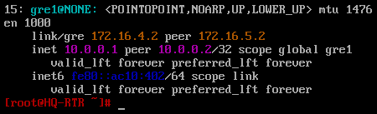

**BR-RTR**

1. mkdir /etc/net/ifaces/gre1

**2.** nano /etc/net/ifaces/gre1/options 🡪

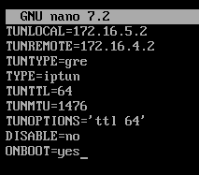

**3.** nano /etc/net/ifaces/gre1/ipv4address 🡪 10.0.0.2 peer 10.0.0.1

systemctl restart network

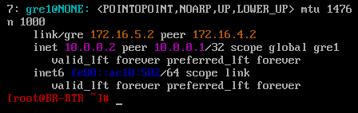

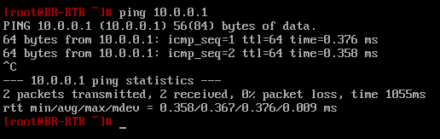

**HQ-RTR и BR-RTR**

**1.** apt-get install frr –y

**2.** nano /etc/frr/daemons 🡪 ospdf=yes

**3.** systemctl enable --now frr

**HQ-RTR**

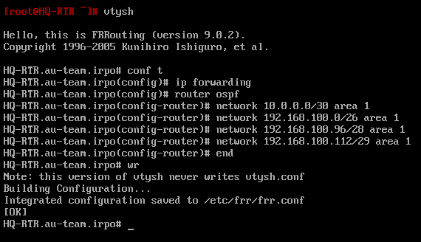

**BR-RTR**

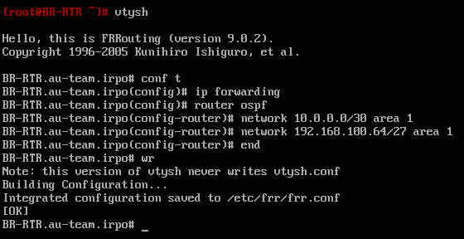

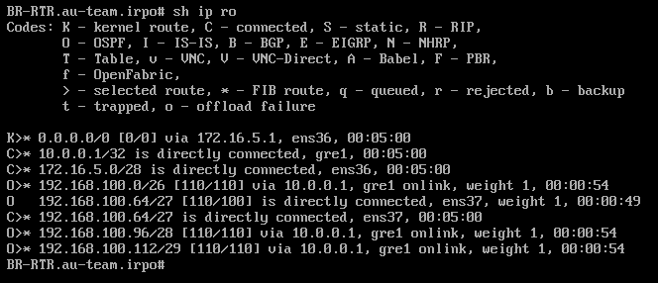

**ISP**

**1.** iptables –t nat –I INPUT –p 47 –j ACCEPT

iptables –t nat –I OUTPUT –p 47 –j ACCEPT

iptables-save > /etc/sysconfig/iptables

**Создание локальных учетных записей + SSH**

**HQ-RTR и BR-RTR**

**1.** adduser net_admin

passwd net_admin 🡪 P@$$w0rd

**2.** nano /etc/sudoers 🡪

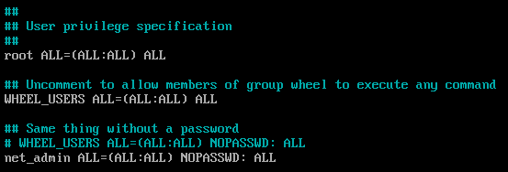

**4.** gpasswd –a sshuser wheel

control sudowheel enabled

reboot

systemctl restart frr

**HQ-SRV и BR-SRV**

**1.** adduser sshuser

passwd sshuser 🡪 P@ssw0rd

**2.** usermod –u 1010 sshuser

id –u sshuser

**3.** nano /etc/sudoers 🡪

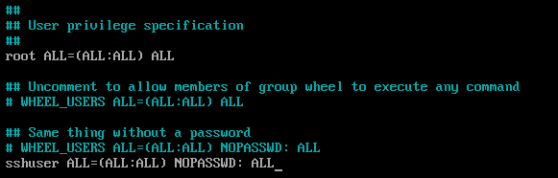

**4.** gpasswd –a sshuser wheel

control sudowheel enabled

reboot

systemctl restart frr

**HQ-SRV и BR-SRV**

**1.** nano /etc/openssh/sshd_config

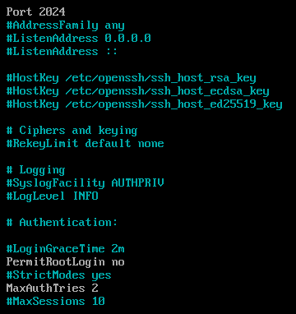





**2.** nano /etc/openssh/banner 🡪 Authorized access only

**3.** systemctl restart sshd

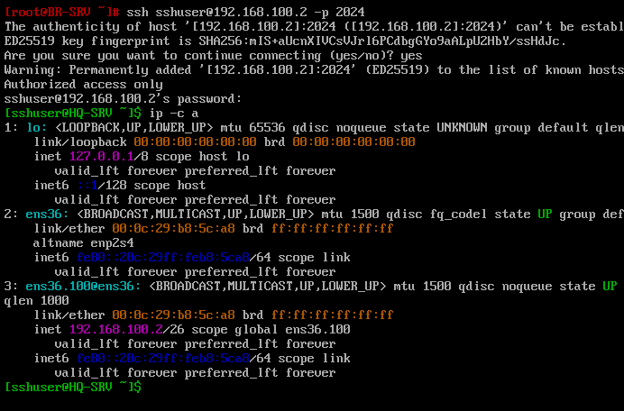

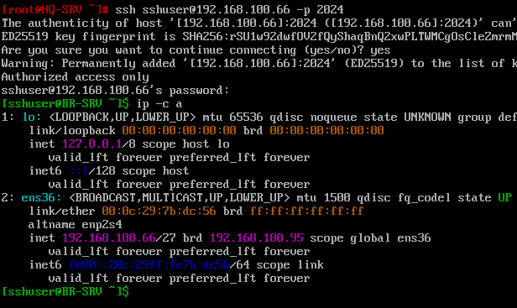

**DNS**

**HQ-SRV**

**1.** apt-get install bind bind-utils –y

**2.** nano /etc/bind/options.conf 🡪

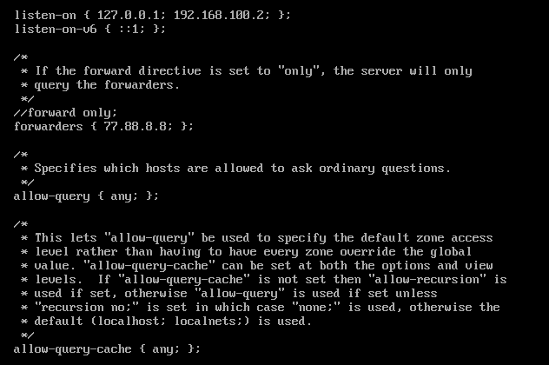

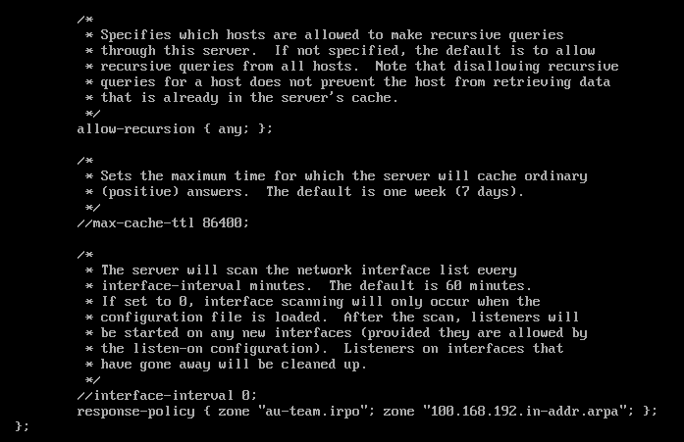

**3.** nano /etc/bind/local.conf 🡪

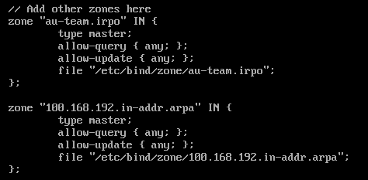

**4.** cp –R /etc/bind/zone/empty /etc/bind/zone/au-team.irpo

cp –R /etc/bind/zone/127.in-addr.arpa /etc/bind/zone/100.168.192.in-addr.arpa

**5.** nano /etc/bind/zone/au-team.irpo 🡪

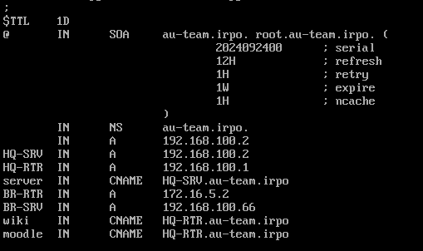

**6.** nano /etc/bind/zone/100.168.192.in-addr.arpa 🡪

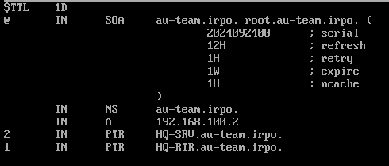

**7.** chown –R named:named /etc/bind/zone/au-team.irpo

chown –R named:named /etc/bind/zone/100.168.192.in-addr.arpa

systemctl restart bind

**8.** nano /etc/resolv.conf 🡪 domain au-team.irpo; nameserver 192.168.100.2

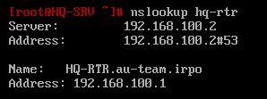

**DHCP**

**HQ-RTR**

**1.** apt-get install dhcp

**2.** cp –R /etc/dhcp/dhcpd.conf.example /etc/dhcp/dhcpd.conf

**3.** nano /etc/dhcp/dhcpd.conf 🡪

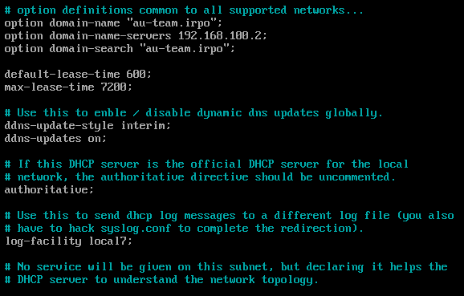

После строки “DHCP server to understand the network topology” всё удаляем и пишем:

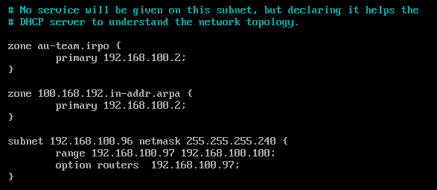

**4.** nano /etc/sysconfig/dhcpd 🡪



systemctl restart dhcpd

**HQ-CLI**

**1.** mcedit /etc/hostname 🡪 HQ-CLI.au-team.irpo

reboot

**2.** mkdir /etc/net/ifaces/ens36

mkdir /etc/net/ifaces/ens36.200

**4.** mcedit /etc/net/ifaces/ens36/options 🡪 TYPE=eth; BOOTPROTO=**static**; ONBOOT=yes

mcedit /etc/net/ifaces/ens36.200/options 🡪 TYPE=vlan; HOST=ens36; VID=200; BOOTPROTO=**dhcp**; ONBOOT=yes

**5.** systemctl restart network

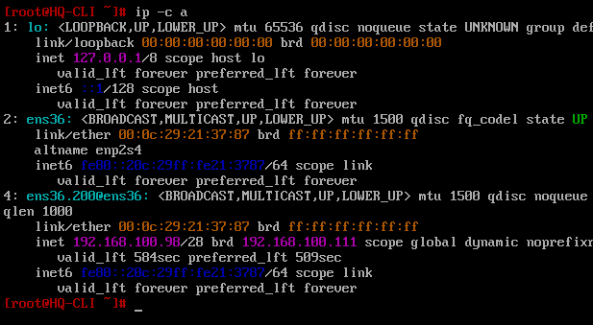

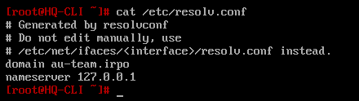

Вообще должно быть так:

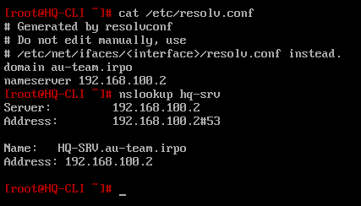

**Завершение**

**1.** Проверяем прямую и обратную зоны на HQ-SRV

nano /etc/bind/zone/au-team.irpo 🡪

Должно быть так:

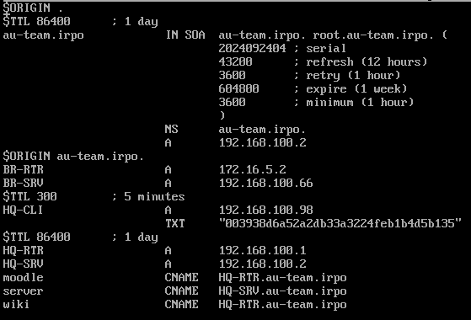

nano /etc/bind/zone/100.168.192.in-addr.arpa 🡪

Должно быть так:

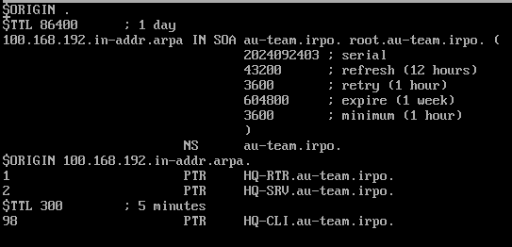

**2.** На всех машинах, кроме ISP, пишем в /etc/resolv.conf 🡪 domain au-team.irpo; nameserver 192.168.100.2

**3.** На всех машинах прописываем timedatectl set-timezone Europe/Moscow